Team 1 Open Source Air Quality Monitoring

Week 14: April 10th 2022 - April 17th 2022

Sponsor: Dr. [David Burnett](mailto:dburnett@pdx.edu)

Advisor: Dr. John Acken

Team Members: [Adam Dezay](mailto:adezay@pdx.edu), [Manuel Garcia](mailto:manga2@pdx.edu), [Brandon Hippe](mailto:bhippe@pdx.edu), Mercedes Newton

**Team Review:**

* Team members are each working on specified sensor/component tasks.
* Team submitted new equipment request
  + Alternative anemometer
  + Jumper cables for PM sensor
* Gantt chart and schedule for current term (shown in figure 1).
* Team decided to meet in person each week on campus at 2pm on Thursdays before advisor meetings
* Team will meet with Dr. Burnett for the next two weeks while Dr. Acken is at conferences.
* Shifting emphasis to meshing codes

**Individual Review**

Adam Dezay:

Worked Soldering connections to see if I am able to get a proper signal from the sensor. Debugging code once uploaded to the sensor

Helped prepare update 1 presentation.

Manuel Garcia:

Worked on learning more about UART & setting up a ESP8266 web server connected to the MSP430 to show proof of concept. Unable to currently get the smartmesh system working, but think the problem was with my individual module. I will be testing a few more modules this week and attempting to finalize the smartmesh portion of this project preparing for integration.

Brandon Hippe:

Worked to debug issues compiling sensor code. Discovered that we need cables for PM sensors. Worked to find a new anemometer alternative. Still working on ultrasonic anemometer.

Mercedes Newton:

PM2.5 sensor updates - Working on connecting PM2.5 sensor to Energia and producing working code. Libraries are created and code runs on ½ computers. Waiting on jumper cables to connect sensor to energia.

Coordinated team planning for upcoming term and updated gantt charts.

**Gantt Chart and Timeline Updates:**

Below is both the timeline of the projected project progress for spring term. Figure 1 represents the gantt chart for the term with expected completion dates beginning March 25th. All specific dates for the upcoming term are specified in the table below.

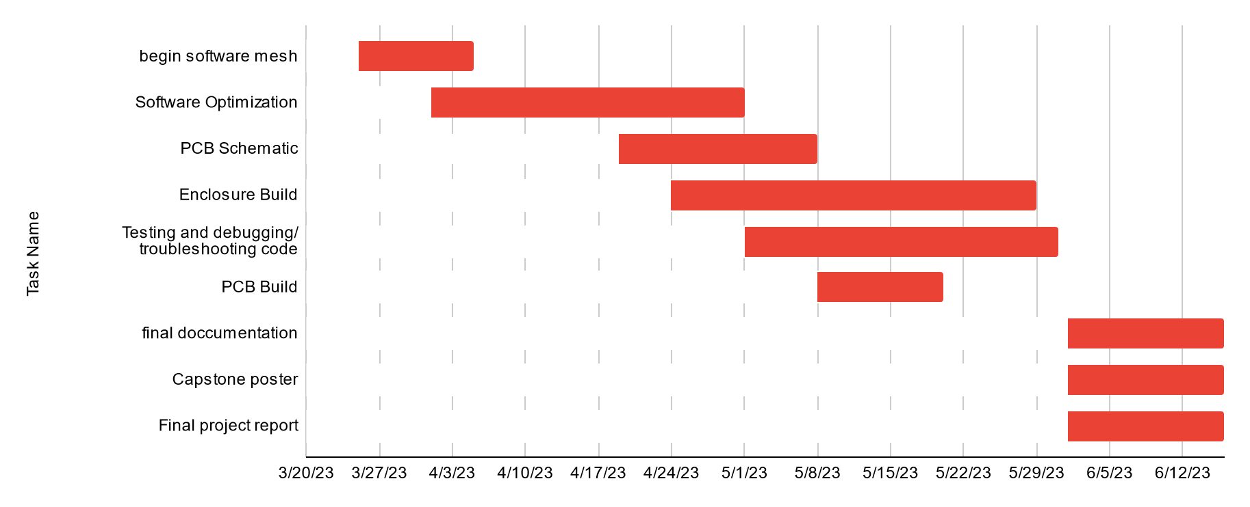

Figure One: Gantt chart for spring term (first task starts 3/25/2013)

| Task Name | Start date | End date |
| --- | --- | --- |
| Begin software mesh | 3/25/2023 | 4/5/2023 |
| Software Optimization | 4/1/2023 | 5/1/2023 |
| PCB Schematic | 4/19/2023 | 5/8/2023 |
| Enclosure Build | 4/24/2023 | 5/29/2023 |
| Testing and debugging/ troubleshooting code | 5/1/2023 | 5/31/2023 |
| PCB Build | 5/8/2023 | 5/20/2023 |
| final documentation | 6/1/2023 | 6/16/2023 |
| Capstone poster | 6/1/2023 | 6/16/2023 |
| Final project report | 6/1/2023 | 6/16/2023 |

Table One: Tasks for spring term with expected completion dates *completion dates subject to change*